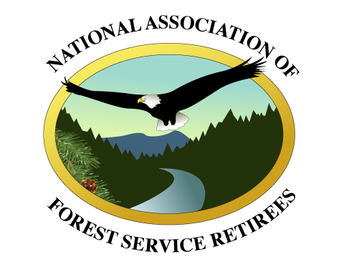

July 26, 2019

Board of Directors

James Caswell, Chair

Larry Payne, Vice Chair

James Golden, Past Chair

Johnny Hodges, Secretary

Richard Stem

Tom Thompson

Greg Griffith

Jack Troyer

Steven Eubanks

Michael Rogers

Ranotta McNair

Malcolm “Mac” Gramley

Don Howlett

Pete Griffin

Rich Guldin

Hank Kashdan

Jane Kollmeyer

Bill Timko

Susan Giannettino
Becki Lockett Heath

Chiefs Emeritus

R. Max Peterson

F. Dale Robertson

Michael Dombeck

Dale Bosworth

Abigail Kimbell
Tom Tidwell

Dear Secretary Perdue:

On behalf of the membership of the National Association of Forest Service Retirees (NAFSR), I would like to thank you for the ongoing dialogue regarding management of National Forest lands. Our organization is passionate about seeking solutions to the challenges faced by the Forest Service and has offered perspectives and suggestions related to Endangered Species Act (ESA) processes, National Environmental Policy Act (NEPA) reform and increased agency funding. This letter and complementary “Increasing Workforce Capacity” report presents NAFSR’s research, analysis and recommendations for growing agency capacity. It is imperative to note that action must be taken to address all of the above-mentioned issues to facilitate a real and sustainable increase in the pace and scale of landscape restoration.

Our fact-finding for this report consisted of two primary components: a quantitative analysis of agency-provided information regarding management and personnel levels over the years, and a qualitative analysis of information gleaned from in-depth interviews with current agency employees. Our resounding conclusion is that the Forest Service cannot meet national direction to increase the pace and scale of forest restoration with its current workforce.

That said, there are some findings to celebrate. Specifically, morale remains surprisingly high. Agency employees remain among the most dedicated, hard-working employees in the federal government even when faced with complex land management challenges and fewer personnel managing larger land bases. For the most part, local working relationships are strong. This is a solid foundation upon which to build.

There are also some serious and troubling trends. Not only has the Forest Service workforce been significantly downsized in recent decades, it has transitioned to a fire-oriented organization that lacks sufficient skills to plan and implement the desired types and levels of vegetative restoration treatments. To successfully implement a program that increases the pace and scale of restoration, the agency must reverse this trend, growing the workforce and hiring those with the skills necessary to perform the work.

Given current hiring procedures, this will be no easy task. To put it bluntly, the existing hiring process is broken. Units report that it can take up to a year to fill a vacancy, and that there is little ability to influence the process. Decisions regarding hiring are often made by personnel in a centralized system that is seemingly disconnected from the field. This situation must be fixed.

Based on our study, NAFSR strongly recommends you take the following actions:

- Hire employees with skills sets necessary to increase the pace and scale of forest restoration.
- Totally revamp the hiring process, streamlining procedures, removing all roadblocks and restoring connections with field units.
- Eliminate unnecessary administrative burdens.
- Increase funding to hire new employees, contract work and enter into partnerships.
- Delegate authority to field units.
- Implement all actions previously suggested by NAFSR, including administrative reforms and the 2021 budget initiative.

With 80 million acres of national forest system lands at high risk of catastrophic wildfire, the agency must take bold action to improve resource conditions. While there will be a hefty upfront price tag associated with action, the cost of no action will be far more costly in terms of dollars and loss of property, human lives and resource destruction.

While NAFSR has done its best to package workforce information and recommendations in this ten-page report, we realize it likely does not answer all your questions or address all potential solutions. In fact, a briefing or follow-up discussion would likely benefit both parties; therefore, we would welcome an opportunity to continue our ongoing dialogue at your convenience.

The membership of NAFSR applauds your strong leadership, Secretary Perdue, noting your recent national proposal to streamline NEPA. We encourage you take immediate action to reform administrative processes, increase budget levels, and hire the workforce needed to take the management actions necessary to create and maintain resilient landscapes and communities across the nation. As always, NAFSR stands ready to work with you to make a great agency even better.

Sincerely,

James L. Caswell
James L. Caswell, Chair

Attachment: “Increasing Workforce Capacity to Increase the Pace and Scale of Restoration on National Forest System Lands”

cc: Campbell Shuford
Jim Hubbard
Doug Crandall
Chief Christiansen

