Analysis of Predicted Probability of Ignition (PIG) for 2020 Mt. Rushmore Fireworks
Forecast for July 3, 2020 @ 21:00 - 21:30MDT
Fire Behavior Analyst: Mike Beasley

Assumptions
- Uses weather record from Mt. Rushmore Remote Automated Weather Station (RAWS) #392603
- Uses day time fuel moisture reference tables (Appendix B), rather than night time tables (Appendix A), per NWCG guidance, despite fireworks being slated for 9:15-9:30 MDT
- Rain Caveat: If at any point prior to the fireworks, a wetting rain occurs, the 1-hr. TLFM resets to 30% and the fuel drying algorithm starts over, effectively making your PIG 0% (see Appendix D)

Climatology

The Black Hills and specifically the area around Mt. Rushmore are experiencing an above average fire danger as shown in the following ERC charts for the northern and southern Black Hills. While, well below historic maxima, this is consistent with the Moderate Fire Danger rating for the peak of the burning period forecasted for July 3rd. Wildfire Today has reported on the Moderate Drought level for the region as assessed by the Drought Monitor.

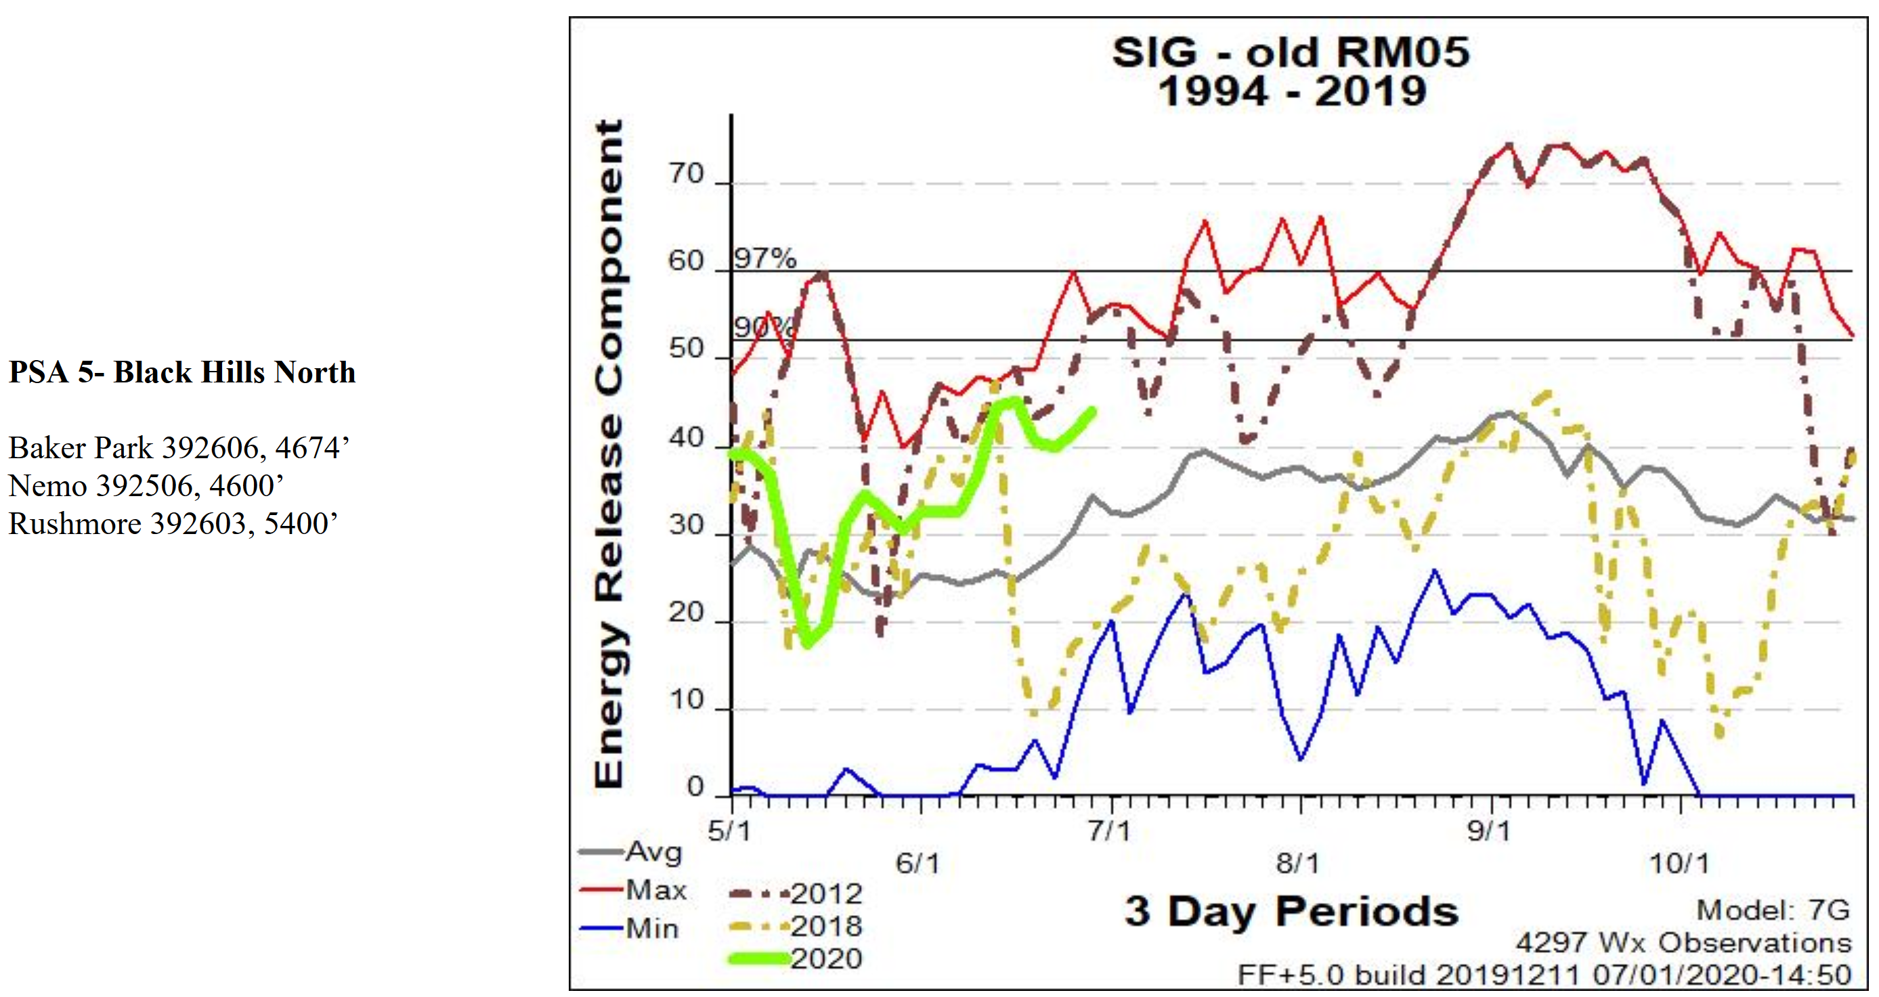

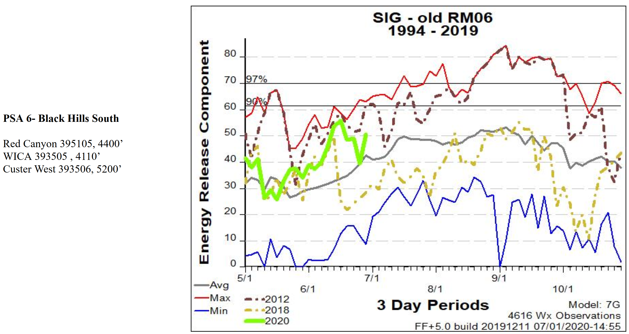
Source: Rocky Mountain GACC Predictive Services

Inputs

The only two inputs for PIG are air temperature and 1-hr. time lag fuel moisture (TLFM). Both are highly variable with the daily diurnal cycle. The Mt. Rushmore RAWS data input daily has yielded the following fuel moistures predicted for mid-afternoon tomorrow immediately before the firework display. While not inputs for the PIG they are given as a general reference.

10-hr TLFM: 8%
100-hr TLFM: 9%
1000-hr TLFM: 12%

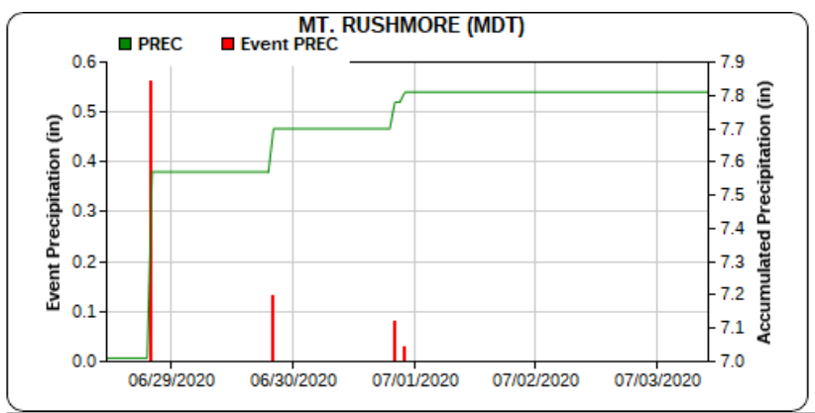
Oddly enough, with an important go/no-go decision to be made around a Presidential visit to Mt. Rushmore, there are no current spot weather forecast requests at the Rapid City NWS forecasting office, except one for the Newcastle fireworks display. In fact, there are two completed spot forecasts for Newcastle on both the 2nd and 3rd of July. That forecast is of little use for Mt. Rushmore, since the Monument is 600’ higher in elevation and many miles to east.

Recent Precipitation: The Mt. Rushmore RAWS received nearly eight tenths of an inch between June 28th and July 1st. That rain aided in the control of a nearby fire in Custer State Park, but there has been no subsequent precipitation.

There has been precipitation around the Black Hills over the past 24 hours, but it has missed Mt. Rushmore. The NWS estimate below shows, over the past 24 hours scattered sites near Mt. Rushmore may have received as much as another half to three-quarter inches, but the gap shows over the Monument.

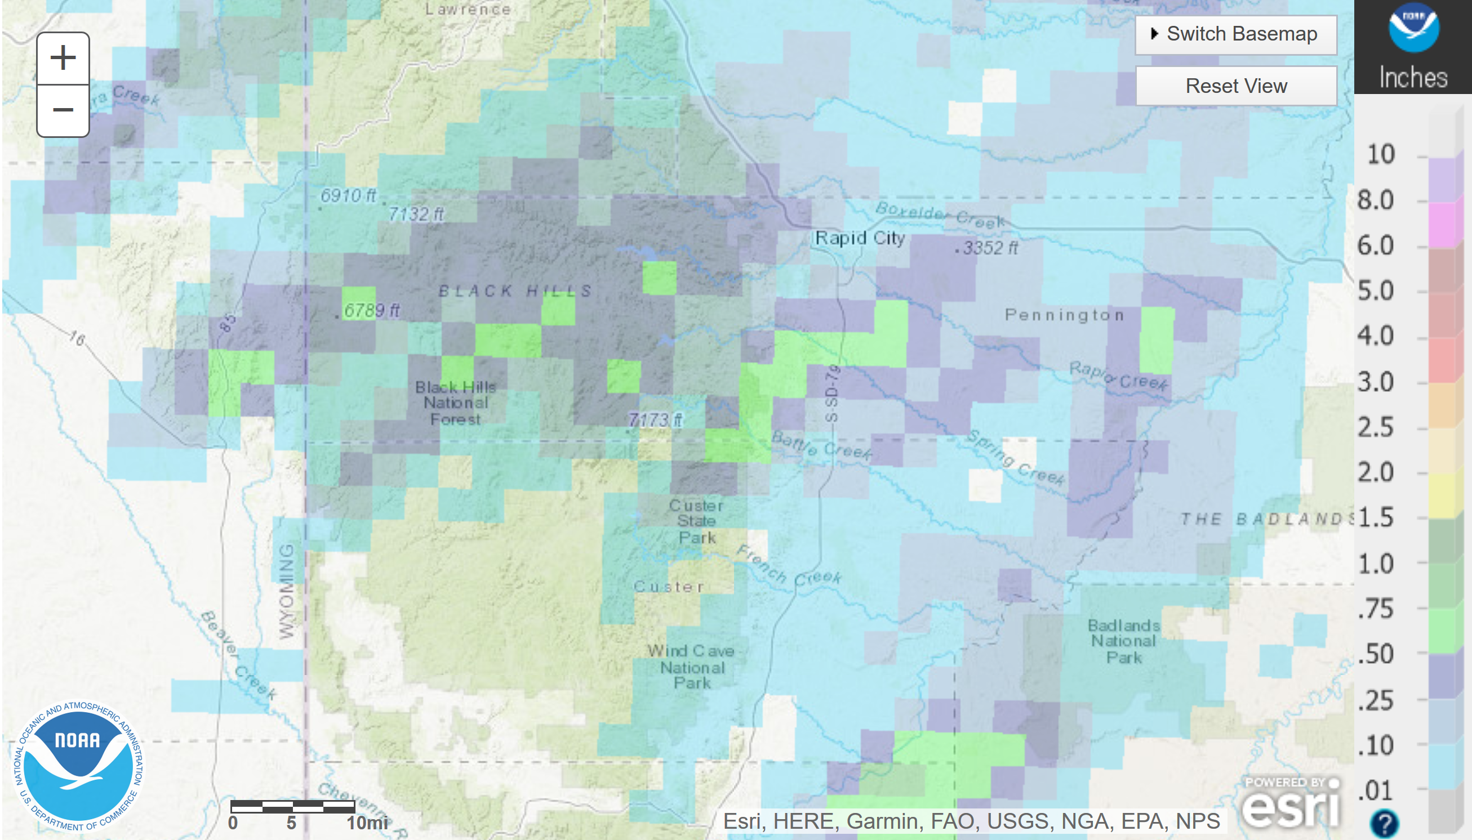

Estimated temperature during the fireworks. Since we don’t have a site-specific weather forecast, we will use the more generalized NWS fire weather forecast and look at persistence over the past two dry evenings, understanding that the region is moving into a hotter, drier period.

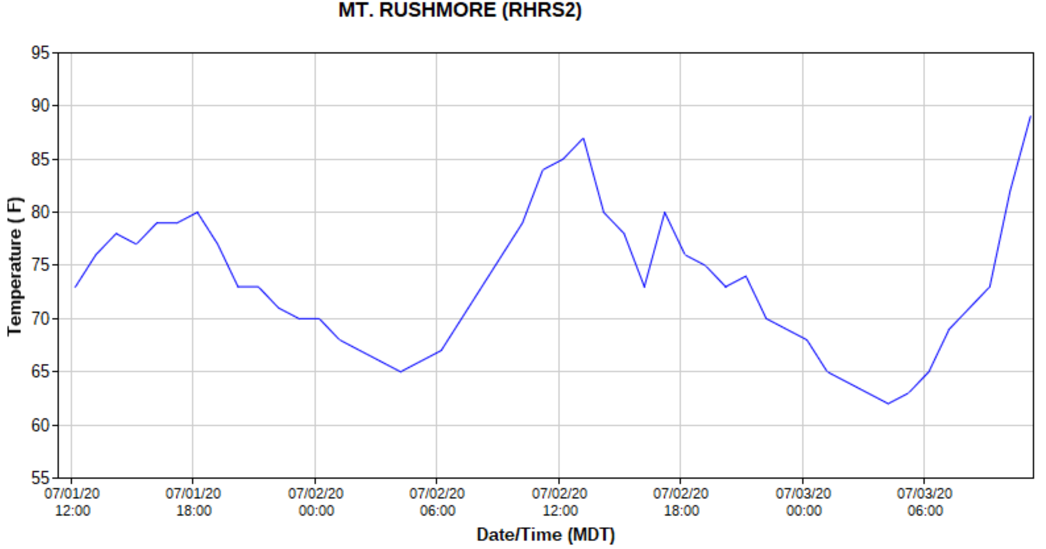
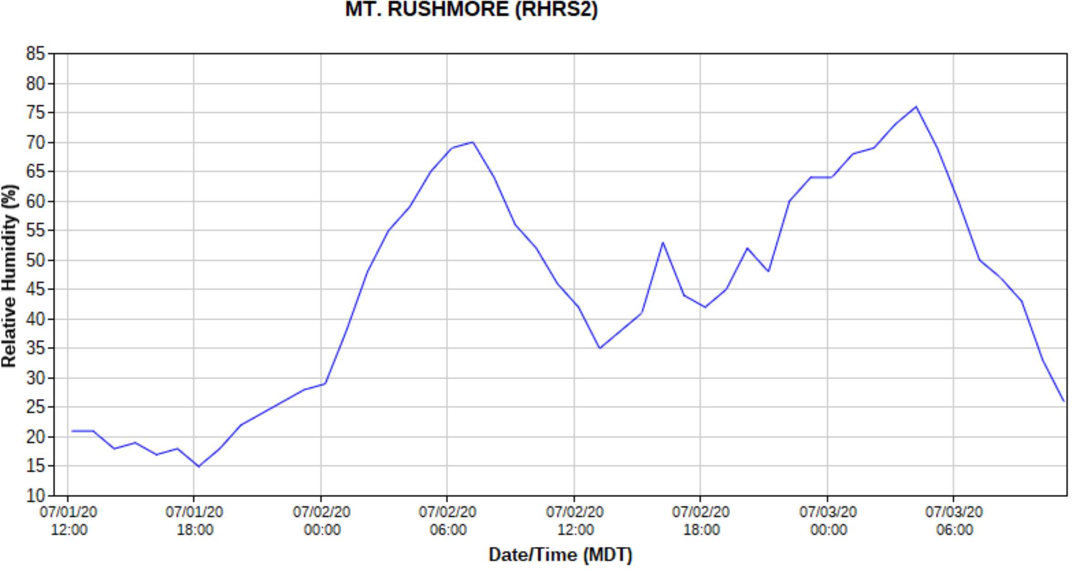
20:00-22:00 Temp July 1
72-76֯
20:00-22:00 RH July 1
18-24%
20:00-22:00 Temp July 2
70-73֯
20:00-22:00 RH July 2
45-55% (note: yesterday afternoon was cooler and moister with passing storm clouds)

Michael A. Fosberg and John E. Deeming (1971) documented procedures for estimating 1 and 10-hour Timelag Fuel Moistures. The methodology, along with seasonal adjustment tables, were integrated into Richard Rothermel’s (1983) tools and methods for surface fire behavior predictions. Using that process, there are no corrections for the nighttime 20:00 to 22:00 time frame on the driest slopes, so the reference 1-hr. TLFM in the early evening would be 4% going to as high as 16% by 04:00 with the forecasted maximum humidity of 78% and a low temperature of 54֯.

The current NWCG web page on dead fuel moisture content discourages use of the nighttime tables, saying this:
Nighttime Estimates of 1-hr Fuel Moisture
Published Reference Fuel Moisture and Correction Tables for Nighttime Conditions are not included here based on recommendation from Pat Andrews at the Missoula Fire Lab. She recommends:
- Estimate Dry Bulb Temperature and RH for the location of interest.
- Use Table A (Appendix B) to estimate the Reference Fuel Moisture.
- Use the appropriate 1-hr Moisture Content Correction Table based on the time of the year.
- Obtain the correction for 0800, shaded conditions, and appropriate aspect from that table and add it to the Reference Fuel Moisture to estimate 1-hr moisture content for nighttime conditions.
Using this methodology, our minimum correction for June in a shaded condition is 4%. Through the course of the evening, the reference moisture will range from 2% in the early evening to 10% at 04:00. That gives us a slightly tighter range of 6-14% after applying the 4% correction. The fireworks will begin at the driest end of this scale, and fuel conditions will moderate throughout the evening. Using the PIG table in Appendix C, starting with a 6% 1-hr. TLFM and the 70-79֯ shaded temperature range, this yields a 50% PIG at the onset of the fireworks display. The PIG could drop to 10% by 04:00 in the early morning before dawn. These results are validated using the BehavePlus software tool for estimating fire behavior, and those results are shown in Appendix D. A 30% 1-hr TLFM is included to reflect the wet fuel stick/fuel bed condition arising, should any wetting rain materialize before the show. That would exceed the moisture of extinction and reduce the PIG to 0%. There is a lingering chance of showers this evening over the Black Hills.

Appendix A
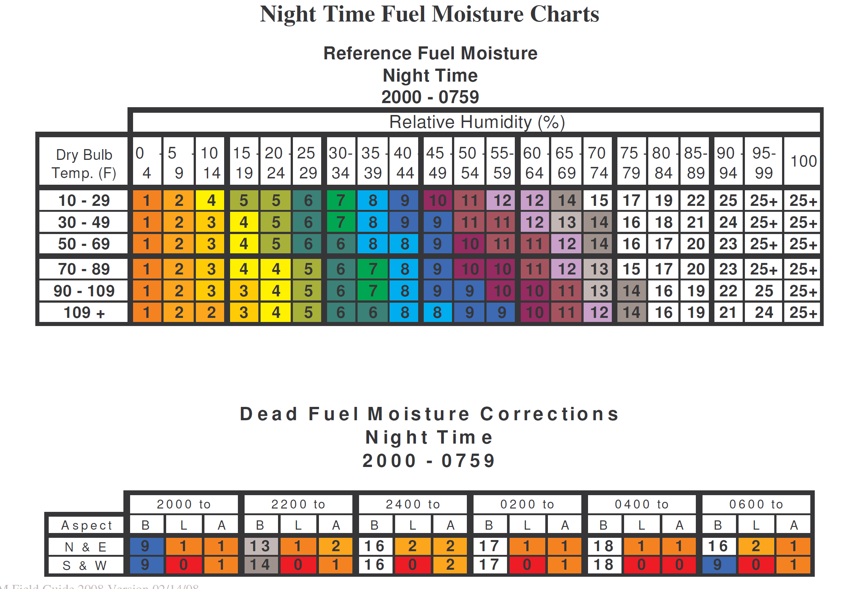
Appendix B

Table A. Reference Fuel Moisture
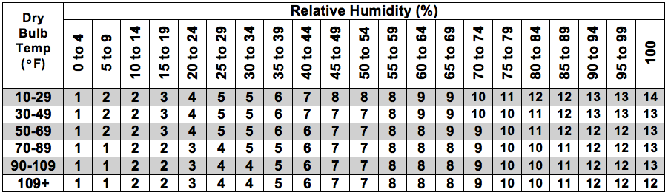

Table B. 1-hr Fuel Moisture Corrections-May-June-July
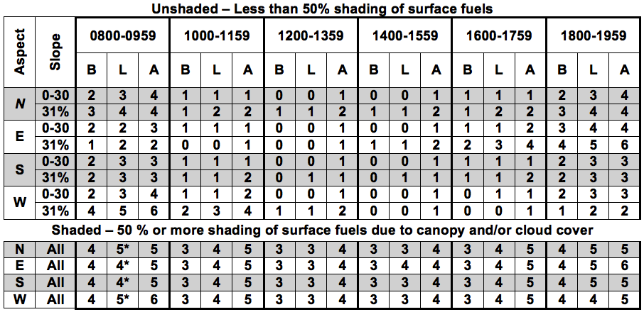
Appendix C
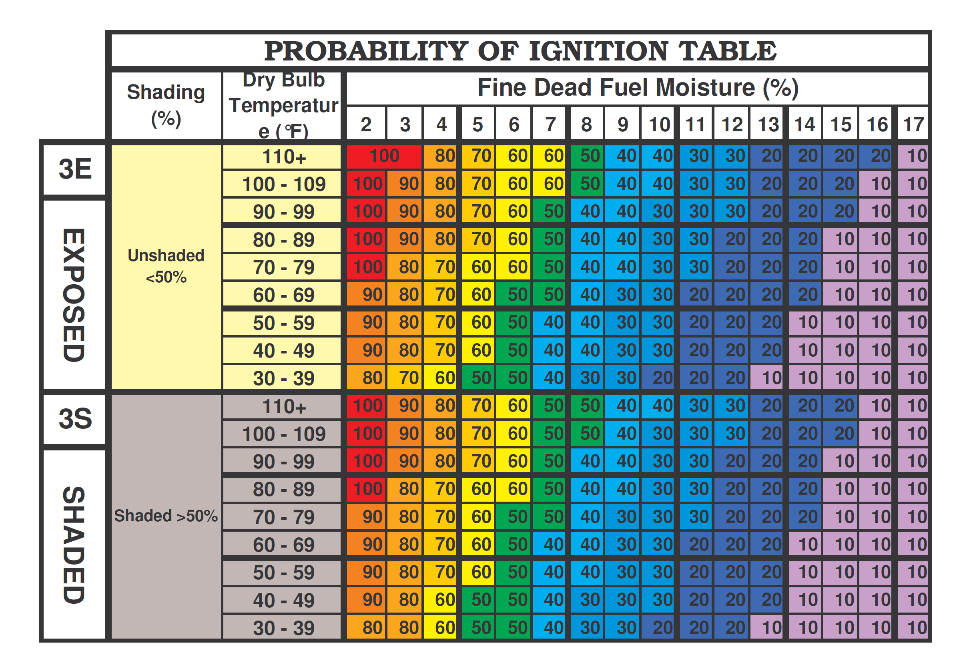
Appendix D
